1. Priest Hierarchy & Occupancy Map
The Temple currently has rooms.
It doesn't have people.
Need:

High Priestess
Office
Bedroom
Private shrine

Senior Priestesses
Where do they live?
How many?

Temple Guards
Where are they stationed?

Novices
Where do they sleep?

Attendants
Where do they work?

Example:
Temple Population
1 High Priestess
4 Senior Priestesses
12 Priestesses
20 Novices
10 Temple Guards
8 Administrative Staff
This helps crowd scenes.

2. Main Hall Seating Canon
Currently:
Main Hall
Capacity 700
Need:

Priest Seating

Noble Seating

Public Seating

Imperial Seating

Ceremony Formation

Otherwise every ceremony scene will look different.

3. Resurrection Ritual Layout
Very important because it launches Midori's entire Fantasy Arc.
Need:
Crystal of Life
|
|
Midori
|
|
12 Priest Stations
with exact positions.
Need:
- who stands where
- ritual circle design
- crystal height
- lighting state

4. Mana Crystal Classification System
This is one of the biggest missing lore items.
Current canon says:
Small
Medium
Large
Sacred
Need:

Physical dimensions

Color

Storage requirements

Typical uses
Example:
Small
5-10 cm
Training
Medium
20-40 cm
Temple lighting
Large
1-2 m
Military use
Sacred
Unique artifacts

5. Staff Maintenance Chamber
Currently buried inside Mana Crystal Storage.
I would promote it to a named location.
Reason:
Midori's staff is a major story object.
Need:

Workbench

Crystal analysis equipment

Sealed crystal lockers

Priest-artificer stations

This room will probably appear repeatedly.

6. Temple Symbol Bible
You have the symbol.
Need rules.
Example:

Large Temple Crest
Main Hall

Medium Crest
Official documents

Small Crest
Priest uniforms

Sacred Crest
Inner Sanctum only

This prevents artists from inventing new variants.

7. Lighting Bible (Temple Specific)
You did this for Suzuki Residence.
Temple needs it too.

Morning

Noon

Evening

Night

Ritual Mode

Resurrection Mode

Emergency Mode

Especially:

Resurrection Mode
Could become visually iconic.
Example:
All ambient lights extinguished.
Only Crystal of Life active.
Strong blue-white illumination.
Heavy shadows.

8. Sacred Artifact Registry
You started this but I would expand it.
Current list:
- Crystal of Life
- Staff of Eternal Light
- Divine Records
- Ancient Relics
- Goddess Icon
Add:

Artifact ID

Current Location

Access Level

Last Known Status

Story Importance
This becomes invaluable 200 chapters later.

9. Temple Timeline
One thing that's completely missing.
Need:
Founded
↓
First High Priestess
↓
Demon War
↓
Midori Resurrection
↓
Current Day
This is useful for flashbacks.

Let us start with the temple timeline, as that's one of the most important plot devices in this arc.
1. Midori dies in Arc 2/3
2. In the dimension where the Gods live, there are three Goddesses of interest: Terra (the Goddess assigned to Earth), Zorna (the Goddess assigned to the Zoran Empire, and Nyssara (the Goddess assigned to the demon race). Note that the demons are visually very similar to humans, but with small pointed ears (like romulans or vulcans in Star Trek). Terra is clearly higher in the Goddess hierarchy than Zorna and Nyssara. Zorna and Nyssara are competing with each other to raise their level. They are playing a game with their races to determine which approach is better to advance civilization: magic (humans/Zorna) or technology (Nyssara). Whichever race wipes out or subjugates the other wins their Goddess the promotion (though humans and demons are pawns and don't realize their role in the game at this point). Zorna wants to cheat and use humans from Earth to become mages for the Zoran Empire because Earthly humans can, genetically, control magic better. Terra wants no part of this game and refuses to provide humans who've passed on to Zorna.
3. Terra is called away on "Godly business" at one point and has Zorna sit in for her as the Goddess of Earth while she is away. During this time Midori dies on Earth and Zorna determines that she has a high disposition for magic. She puts Midori on hold for a bit before reincarnating her.
4. While Midori is waiting, Zorna goes back in time 200 years and appears before a Zoran woman (Ashiba), telling her she is a prophet that will help bring victory in the demon wars (waging for about 100 years at that point). Although Zoran humans have discovered magic at that point, they are not capable of much beyond minor parlor tricks and weak defensive and healing magic. Zorna advances Ashiba's knowledge a bit and convinces her to start a religion geared towards magic. Zorna also teaches here about mana crystals (and warns her that the crystals will burn and injure humans if not properly shielded. Zorna also tells Ashiba to prepare for the arrival of a grand mage 200 years hence; she must prepare a resurrection chamber according to the specifications Zorna provides and she must teach the priestesses that follow to wait for, and resurrect this grand mage when she arrives.
5. Ashiba founds the church as a matriarchal organization that teaches mages (male and female) through the ancillary Zoran academy and also prepares for the arrival of the grand mage. The best of the female Zoran academy students become priestesses in the Zoran Temple. The resurrection chamber is staffed with 10 Zoran priestesses constantly (10 herors a day, where the day is roughly the same as Earth's), every day of every mon (mon) of the yur (year) waiting for the arrival of the grand mage. Zonra tells Ashiba that the mage will appear 200 years hence, but that the resurrection room must be continuously staffed until the mage arrives.
6. Based on the knowledge Zorna provides, the Zoran humans rapidly advance with their ability to use magic and begin to get the upper hand in the battle with the demons.
7. Zorna returns to the Dimension of the Gods, returning just a few minutes after Midori appeared there. The Gods have rules, and the soul who has just passed away must decide how they will proceed at that point: reincarnated without memories of their past life on their World, reincarnate to another world (generally a developing world) to help build up that world, or remain in the Dimension of the Gods as an acolyte. Most souls (say 80%) choose the first option, another large percentage (say 15%) choose to remain. Only a small percent (5%) choose the second option because the Gods are usually honest and present a picture of hardship and pain for that route (the only benefit being keeping your memories). Zorna is wicked and lies to Midori about the problems with the second option. She emphasizes the ability to use magic and gain great personal power and tells (truthfully) Midori that she will be one of the strongest mages in that world. She even tells Midori that she could gain enough power to return home to Earth (which is true, though she leaves out the fact that time advances much more slowly on the fantasy world [Zora] and a few years there will correspond to several hundred (about 200 Earth years for every Zoran year).
8. Midori, wanting the power to return back to Earth and right all the wrongs against her parents and herself, reluctantly chooses the second option.
9. Zorna prepares to send Midori to Zora during the resurrection ritual 200 years, to the date, after Zorna first appeared before Ashiba.
10. 10 priestesses are in the resurrection chamber when Zorna "resurrects" Midori on the Zoran world. Midori appears, and the priestesses are overjoyed and remove Midori to the head priestess' chambers. Immediately after the resurrection, the resurrection room self-destructs (though it doesn't damage anything else in the temple).
11. The head priestess was expecting a fully trained "Grand Mage" and is disappointed to discover that Midori is illiterate (at least in Zoran) and incapable of using even the simplest spells. Worse yet, Midori has the black hair of the demons. The head priestess is unsure what to do about this as all Zorans have platinum blonde hair and the priestess realizes this will create problems.
12. The head priestess assigns a set of six priestesses who tutor Midori 4 herors a day (about 8-9 hours). Midori is annoyed, but is used to this from her time in the temple on Earth.
13. Once Midori achieves basic literacy, the head priestess enrolls her at the academy.
14. Because the arrival of Midori completes the purpose of the Zoran temple, the head priestess is unsure what to do. However, because she wields vast political power, she shifts the purpose of the temple from waiting for the Grand Mage to controlling the mana crystals and magic the humans use to combat the demons. She uses Midori's black hair as a symbol of her continuing control over the religion ("The temple must guide her to ensure no demonic tendencies appear.")
15. Midori enrolls at the academy. She is assigned to a dorm room with her soon-to-be-friends Adnil, Naandeen, and Zarleen. Of course, she is greeted by great prejudice everywhere in the academy. It takes a little while for Adnil, Naandeen, and Zarleen to warm up to her (mainly, being the "chosen one" is what wins them over in the beginning).
16. That brings us to the Academy arc of the second portion of the story.

ZORAN TEMPLE TIMELINE v1.0

(Internal Story Bible – Not for Publication)

~300 Years Before Midori's Arrival
The War Begins
- Human Kingdoms and Demon Kingdoms compete for territory.
- Magic exists but is primitive.
- Human mages are capable only of:
  - Minor healing
  - Weak defensive barriers
  - Small utility spells
- Demon technology develops more rapidly than human magic.
- The war slowly turns against humanity.

~200 Years Before Midori's Arrival
Terra Leaves the Earth Domain
- Terra, Goddess of Earth, is temporarily called away on higher divine business.
- Zorna assumes responsibility for Earth during Terra's absence.
- Nyssara continues directing the Demon civilization.
- Zorna and Nyssara remain engaged in their long-running competition over whether magic or technology is the superior path for advancing civilization.

Shortly Thereafter
Midori Dies on Earth
- Midori dies during Arc 2/3.
- Her soul arrives in the Dimension of the Gods.
- Zorna detects that Midori has an exceptionally high innate affinity for controlling mana.
- Rather than immediately processing her soul, Zorna secretly places Midori's reincarnation on hold.
No one else in the divine bureaucracy realizes Midori has been set aside.

Immediately Afterward
Zorna Alters History
Using divine authority over Zora—but not Earth—Zorna travels approximately 200 years into Zora's past.
She appears before a young Zoran woman named Ashiba.

The Revelation to Ashiba
Zorna tells Ashiba:
- Humanity will one day receive a Grand Mage.
- The Temple must be founded immediately.
- The Grand Mage will arrive exactly 200 years in the future.
- A Resurrection Chamber must be constructed according to divine specifications.
- Mana crystals are gifts of the Goddess but are dangerous if left unshielded.
- The Temple must preserve knowledge of mana crystals and teach future generations how to handle them safely.
- The Resurrection Chamber must remain continuously staffed until the Grand Mage appears.
Zorna intentionally withholds:
- Why the Grand Mage is coming.
- Midori's Earthly origin.
- The existence of Terra.
- The competition between the gods.

Founding of the Zoran Temple
Ashiba establishes:
- The Church of the Goddess of Light.
- A matriarchal priesthood.
- The office of the High Priestess.
- The Resurrection Rite.
- The Order of Crystal Guardians.
The Temple becomes both the spiritual and magical authority of the Empire.

Following Decades
The Academy is Established
To support the Temple:
- The Imperial Magic Academy is founded.
- Male and female students may study magic.
- Only the most gifted women are invited into the Temple priesthood.
- Priestesses become both scholars and ritual specialists.

The Mana Revolution
Ashiba's teachings spread.
Human civilization rapidly advances:
- Offensive magic
- Battlefield healing
- Defensive barriers
- Crystal-powered tools
- Large-scale magical engineering
The balance of the war begins shifting toward humanity.

Two Centuries of Waiting
For approximately 200 years:
Every day...
Every mon...
Every yur...
The Resurrection Chamber is continuously staffed.
Five priestesses remain on duty at all times, rotating in five-heror shifts.
No one knows whether the Grand Mage will truly come.
Yet the ritual is never abandoned.
Over generations, this duty becomes the Temple's highest sacred obligation.

The Resurrection Vigil

Temple Canon
Following Ashiba's founding of the Temple, the Resurrection Chamber became the Temple's highest sacred responsibility.
The chamber was never left unattended.
At all times:
- Five Senior Priestesses remained inside the Resurrection Chamber.
- Each watch lasted five herors.
- A Zoran day consists of ten herors, resulting in two watches per day.
- The watch changed precisely at mid-day and midnight according to the Temple's water clock and crystal chronometer.
Thus, every day required:
- 10 Senior Priestess-duty assignments
- 2 ceremonial shift changes
- 1 uninterrupted Resurrection Vigil

The Order of the Resurrection Vigil
The Temple permanently assigned thirty Senior Priestesses to this sacred duty.
They were organized into six Watch Companies, each consisting of five priestesses.
First Watch Company
5 Senior Priestesses
Second Watch Company
5 Senior Priestesses
Third Watch Company
5 Senior Priestesses
Fourth Watch Company
5 Senior Priestesses
Fifth Watch Company
5 Senior Priestesses
Sixth Watch Company
5 Senior Priestesses
Only one company occupied the chamber during a watch.

Rotation Schedule
The companies rotated on a three-day cycle.
A simple example:
Day | First Watch | Second Watch
1 | Company I | Company II
2 | Company III | Company IV
3 | Company V | Company VI
4 | Company I | Company II
Each company therefore served:
- One five-heror watch
- Every three days
This gave each priestess ample time for prayer, instruction, administrative duties, and rest while ensuring that the Resurrection Chamber was never unattended.

Why Five Priestesses?
Ashiba's writings state:
"No sacred work should rest upon one pair of hands alone."
The five members of each watch had distinct ceremonial roles:
- Watch Captain – directed the ritual and maintained the chamber log.
- Crystal Warden – monitored the Crystal of Life and the mana shielding.
- Circle Keeper – inspected the resurrection circle and mana channels.
- Prayer Keeper – maintained the continuous liturgy during the watch.
- Archivist – recorded all observations, however ordinary, in the Resurrection Chronicle.
This division of responsibility gives every priestess a meaningful purpose and provides recurring roles you can reuse in scenes.

The Two-Hundred-Year Vigil
For approximately two centuries, the watch was never broken.
Thousands of priestesses served over the generations.
Most never witnessed anything unusual.
Many quietly wondered whether the prophecy would ever be fulfilled.
Nevertheless, each generation faithfully relieved the previous one, believing that if the Grand Mage appeared while the chamber stood empty, humanity's hope might be lost forever.

Meanwhile, Back in the Dimension of the Gods….
Midori Waits
From Midori's perspective, only minutes pass.
Zorna returns.
The normal post-death choices are presented:
- Reincarnate on Earth without previous memories.
- Reincarnate into another developing world while retaining memories.
- Remain in the Dimension of the Gods as an acolyte.
Historically:
- ~80% choose Earth reincarnation.
- ~15% remain as acolytes.
- ~5% choose another world.
Most reject the second option after hearing an honest explanation of the hardship involved.

Zorna's Deception
Zorna privately speaks with Midori.
Everything she says is technically true.
She tells Midori:
- She possesses extraordinary magical potential.
- She could become one of the greatest mages in history.
- She may eventually gain enough power to return to Earth.
- She will retain all of her memories.
She deliberately omits:
- Time passes at dramatically different rates.
- She has manipulated history specifically for Midori's arrival.
- Humanity has been waiting two centuries for her.
- She is a pawn in a contest between gods.
Midori reluctantly accepts reincarnation on Zora.

Day 0
The Grand Mage Arrives
Exactly 200 years after Ashiba's revelation:
The Resurrection Ritual begins.
Five priestesses stand in position.
Midori materializes.
The prophecy is fulfilled.

The Chamber Collapses
Immediately after Midori's resurrection:
The enormous Resurrection Circle engraved into the floor suddenly emits a brilliant blue-white radiance.
The Crystal of Life suspended above Midori begins glowing more brightly than at any point in the Temple's history.
Every mana channel carved into the floor ignites simultaneously.
For several seconds the chamber is filled with an overwhelming light.
Then...
Everything becomes silent.

The Crystal of Life loses all luminosity.
Its surface develops countless fine fractures.
The crystal remains physically intact, but no longer contains any usable mana.
It has become an ordinary crystal.

The Resurrection Circle itself changes permanently.
The intricate glowing channels vitrify into smooth white stone threaded with translucent glass-like veins.
Every rune carved by Ashiba two centuries earlier is fused permanently into the floor.
No amount of magical power can reactivate them.

The mana conduits running through the chamber become inert.
Every measurement performed over the following centuries confirms the same conclusion:
No mana flows through the chamber any longer.

The chamber has not been destroyed.
It has simply...
Completed its purpose.

Temple Interpretation
The High Priestess immediately declares:
"The Goddess has accepted the Offering."
"The Promise has been fulfilled."
"The Chamber has completed its sacred duty."
No attempt is ever made to rebuild it.
The Temple officially seals the room as a holy site.

Long-Term Canon
After Midori's arrival:
The Resurrection Chamber becomes:

The Chamber of Fulfillment
Visitors are prohibited.
No rituals are ever conducted there again.
Instead, it becomes a pilgrimage destination for senior priestesses.

Architectural Changes
The chamber itself remains exactly as it appeared on the day Midori arrived.
Nothing is removed.
Nothing is repaired.
The floor remains permanently fused.
The empty Crystal of Life still hangs above the altar.
The ten priest stations remain untouched.
The chamber is preserved as a sacred historical monument.

Symbolism
This also reinforces one of the Temple's central beliefs:
Ashiba did not build a machine.
She built a promise.
The chamber existed for one purpose only:
To receive the Grand Mage.
Once that purpose was fulfilled, the divine power sustaining it simply departed.

A Nice Story Beat
Years later, after Midori has become one of the Empire's greatest mages, she returns to the chamber.
She notices that no mana can be sensed there at all.
The room feels strangely peaceful.
One of the elderly priestesses quietly says:
"For two hundred years we believed we were waiting for you."
Midori looks around at the silent chamber.
"No..."
She gently places a hand on the now-inert ritual circle.
"You weren't waiting for me."
She looks up at the empty Crystal of Life.
"You were waiting for hope."
That moment would work well because it reframes the prophecy. The Temple wasn't merely anticipating a powerful individual—it had spent generations sustaining faith through a seemingly endless vigil, and Midori comes to appreciate the sacrifice of those who came before her. It also reinforces her empathy, which is one of her defining traits.

Back to the timeline:

The First Shock
The High Priestess expected:
- An adult master mage.
- A fully trained military leader.
- A savior.
Instead she finds:
- A frightened teenage girl.
- Illiterate in the Zoran language.
- Unable to cast even beginner-level spells.
- Black-haired—a feature associated with demons.
The Temple enters a crisis.

The Hidden Decision
Rather than reveal uncertainty:
The High Priestess declares:
"The Grand Mage requires guidance before her divine purpose can be fulfilled."
Privately she begins searching for answers.

Midori's Education
Six priestesses are assigned exclusively to Midori.
Schedule:
- Four herors each day devoted to instruction.
- Language.
- Reading.
- Writing.
- Temple customs.
- Basic magical theory.

Academy Enrollment
After demonstrating basic literacy:
Midori is formally enrolled at the Imperial Magic Academy.

Temple Reorganization
The prophecy fulfilled...
The Temple's original purpose has ended.
The High Priestess issues a historic decree.
The Temple's new mission becomes:
- Guardianship of mana crystals.
- Regulation of magical research.
- Preservation of magical knowledge.
- Spiritual oversight of the Grand Mage.
Publicly she presents Midori's black hair as evidence that the Temple must continue guiding the Chosen Mage, lest "demonic tendencies" emerge.
This reinforces the Temple's authority while protecting Midori from immediate political exploitation.

Beginning of the Academy Arc
Midori enters the Academy.
She is assigned a dormitory room with:
- Adnil
- Naandeen
- Zarleen
She encounters prejudice because of:
- Her black hair.
- Her foreign appearance.
- Her status as the prophesied Grand Mage.
The Academy Arc begins.

10. The Most Important Missing Sheet
If I could add only one thing:

Temple Security & Access Map
Who can go where?
Example:
Location | Public | Priest | Senior Priest | High Priestess
Main Hall | Yes | Yes | Yes | Yes
Inner Sanctum | No | No | Limited | Yes
Resurrection Chamber | No | No | Yes | Yes
Ancient Vault | No | No | No | Yes
This becomes extremely important later when Midori gains privileges she shouldn't normally have.

What I Would Consider "Production Complete"
When the Temple Bible contains:
✅ Architecture
✅ Room layouts
✅ Camera maps
✅ Sight-line matrices
✅ Artifact registry
✅ Security map
✅ Occupancy map
✅ Ritual layout
✅ Mana crystal classification
✅ Temple timeline
✅ Lighting states
At that point, the Zoran Temple would be at the same maturity level as the Suzuki Residence—and probably one of the most thoroughly documented fantasy locations in the entire project.

ZORAN TEMPLE ORGANIZATIONAL STRUCTURE

(Internal Canon)

Total Permanent Population
Position | Number
High Priestess | 1
Deputy High Priestess | 1
Senior Priestesses | 30
Temple Priestesses | 72
Novice Priestesses | 48
Temple Guards | 36
Crystal Wardens | 18
Temple Attendants | 24
Archivists | 8
Administrative Staff | 12
Kitchen Staff | 16
Garden Keepers | 10
Maintenance Artisans | 12
Physicians & Healers | 8
Visiting Academy Students (Typical) | 20–50
Permanent population: ~286 people
This feels appropriate for the religious headquarters of the Zoran Empire.

Organizational Hierarchy
GODDESS ZORNA
│
HIGH PRIESTESS
│
┌────────────┴────────────┐
│ │
Deputy High Priestess Temple Council
│ │
┌───────┼────────┬────────┬────────┐
│ │ │ │
Senior Crystal Archives Education
Priestesses Wardens Division
│
Temple Priestesses
│
Novice Priestesses

High Priestess
Population:
1
Residence:
Private suite adjoining the Inner Sanctum.
Contains:
- Office
- Meeting chamber
- Bedroom
- Private shrine
- Personal archive
- Balcony overlooking the Temple gardens
The High Priestess is the only person with unrestricted access to every room in the Temple.

Deputy High Priestess
Population:
1
Lives in a smaller suite adjacent to the High Priestess.
Responsibilities:
- Temple administration
- Personnel assignments
- Daily operations
- Acts in the High Priestess's absence

Senior Priestesses
Population:
30
These are the Temple's senior leadership.
Primary duties:
- Resurrection Vigil
- Major rituals
- Mentoring
- Political ceremonies
- Crystal supervision
Residence:
A dedicated residential wing (East Wing, second floor).
Each has:
- Private bedroom
- Writing desk
- Wardrobe
- Small prayer alcove
- Shared sitting room
- Shared baths

Resurrection Vigil Companies
The 30 Senior Priestesses are divided into six permanent companies.
Company | Members
Company I | 5
Company II | 5
Company III | 5
Company IV | 5
Company V | 5
Company VI | 5
Each company serves one five-heror watch every three days.

Temple Priestesses
Population:
72
Responsibilities:
- Daily worship
- Public ceremonies
- Teaching
- Healing
- Crystal research
- Administration
Residence:
Temple Dormitory Wing
Rooms:
Two priestesses per room.

Novice Priestesses
Population:
48
Young women selected from the Imperial Magic Academy.
Typical age:
15–20
Training includes:
- Theology
- Etiquette
- Literacy
- Healing
- Crystal handling
- Ritual procedure
Residence:
Novice Dormitory
Four novices per room.

Crystal Wardens
Population:
18
Specialists responsible for:
- Mana crystal inspection
- Safe transport
- Shield maintenance
- Staff maintenance
- Vault security
Residence:
Temple Guard Wing
Most have engineering and magical training rather than administrative duties.

Temple Guards
Population:
36
Unlike ordinary soldiers, Temple Guards are trained to protect sacred spaces and artifacts.
Equipment:
- Spear
- Short sword
- Light enchanted armor
- Crystal alarm talisman
Guard Posts:
- Main Entrance (4)
- Main Hall (4)
- Inner Sanctum (2)
- High Priestess Chambers (2)
- Mana Crystal Storage (8)
- Underground Vault (6)
- Temple Grounds (10 rotating patrols)

Temple Attendants
Population:
24
Responsibilities:
- Cleaning
- Laundry
- Preparing ceremonial robes
- Tea service
- Guest reception
- Maintaining ritual supplies
They do not perform religious ceremonies.
Residence:
Service Wing

Archivists
Population:
8
Responsible for:
- Historical records
- Temple Chronicle
- Resurrection Chronicle
- Mana research records
- Imperial correspondence
Office:
Archive Wing (West Wing)

Administrative Staff
Population:
12
Responsibilities:
- Donations
- Finances
- Scheduling
- Inventory
- Correspondence
Office:
Entrance Hall Administration Offices

Kitchen Staff
Population:
16
Operate:
- Main kitchen
- Bakery
- Dining hall
- Food storage
They prepare meals for all permanent residents.

Garden Keepers
Population:
10
Maintain:
- Reflection Pool
- Prayer Garden
- Memorial Garden
- Courtyards
- Sacred trees

Physicians & Healers
Population:
8
Operate the Temple Infirmary.
Treat:
- Pilgrims
- Priestesses
- Temple staff
- Crystal exposure injuries

Daily Population by Area
This helps when composing scenes:
Area | Typical Occupancy
Main Hall (ordinary day) | 40–80
Main Hall (festival) | 500–700
High Priestess Chambers | 2–8
Inner Sanctum | 1–3
Mana Crystal Storage | 6–12
Resurrection Chamber (before Midori) | 5 Senior Priestesses
Resurrection Chamber (after Midori) | Usually empty; occasional supervised visits
Archives | 2–6
Temple Gardens | 10–30
Dining Hall | 80–140 at meal times

A Story Detail Worth Establishing
I would also add one prestigious honor:

The Order of Ashiba
Every High Priestess selects six Senior Priestesses to serve as her personal council. Membership is for the duration of that High Priestess's tenure and is considered the highest honor below becoming High Priestess. These six women advise on doctrine, oversee the Temple's most sensitive affairs, and, after Midori's arrival, become deeply involved in decisions concerning the Grand Mage.
That gives you a recurring group of named supporting characters instead of an anonymous crowd whenever important Temple decisions are made, making political and religious scenes easier to stage and follow.

Temple Characters

Tier 1 — Principal Characters
Fully developed.
These get:
- Full name
- Age
- Biography
- Character sheet
- Relationships
- Voice
- Goals
- Secrets
For the Temple, I'd have only three.

High Priestess
One of the most important supporting characters in the Fantasy Arc.
She needs a complete character bible (see HIGH PRIESTESS CHARACTER BIBLE.docx)

Deputy High Priestess
She interacts with Midori regularly.
She's the practical administrator while the High Priestess handles politics and doctrine.
Complete character.

Ashiba (Founder)
Although she lived 200 years earlier, she is enormously important.
She deserves:
- appearance sheet
- biography
- philosophy
- relationship to Zorna

Tier 2 — Major Supporting Characters
These recur often enough to deserve names and personalities, but not necessarily full design packets at first.

The Order of Ashiba
The six-member advisory council.
This is the perfect place for recurring Temple characters.
For example:
- Elder Ritualist
- Crystal Master
- Temple Historian
- Healing Mistress
- Keeper of the Archives
- Mistress of Ceremonies
These six should all have names and distinct personalities because they become the faces of the Temple's leadership.

The Order of Ashiba
The Order of Ashiba consists of the six senior priestesses personally appointed by the High Priestess to preserve the teachings of Ashiba and oversee the Temple's most sacred responsibilities.
When Midori arrives, Seraphine assigns the entire Order to her education.
For the next several months, each priestess teaches Midori in her own specialty for approximately four herors each day, creating a rigorous curriculum before Midori is admitted to the Imperial Magic Academy.

1. Sister Aurelia

Keeper of the Prophecy
Age: 63
Temple Office
Keeper of Ashiba's Prophecies
Primary Responsibilities
- Interpretation of prophecy
- Temple doctrine
- Ashiba's writings
- Divine history
Midori's Instructor
Subjects taught:
- Zoran language
- Reading
- Writing
- Religious history
- Ashiba's life
- The history of the Temple
Because Midori arrives completely illiterate in Zoran, Aurelia spends the most time with her during the first months.
She is extraordinarily patient.
She never raises her voice.
She becomes the closest thing Midori has to a grandmother.

2. Sister Helena

Mistress of Ritual
Age: 52
Temple Office
Director of Sacred Ceremonies
Primary Responsibilities
- Temple rituals
- Religious ceremonies
- Priest ordinations
- Imperial blessings
Midori's Instructor
Subjects taught:
- Temple etiquette
- Noble etiquette
- Ceremony procedure
- Public speaking
- Religious customs
She constantly reminds Midori:
"The people will watch every movement you make."
She teaches dignity more than magic.

3. Sister Eliane

Keeper of the Crystal Vault
Age: 45
Temple Office
Master of Mana Crystals
Primary Responsibilities
- Crystal safety
- Staff maintenance
- Mana shielding
- Crystal research
Midori's Instructor
Subjects taught:
- Mana theory
- Crystal radiation
- Safe staff handling
- Mana absorption
- Magical fundamentals
She is the first person to explain why the Staff of Eternal Light remains sealed whenever it is not actively in use.
She also teaches Midori to respect mana rather than fear it.

4. Sister Lucia

Mistress of Instruction
Age: 35 (youngest Senior Priestess/Order of Ashiba Priestess, ever)
Temple Office
Director of Temple Education
Primary Responsibilities
- Novice education
- Curriculum
- Academic standards
- Academy liaison
- Midori's homeroom instructor
Midori's Instructor
Subjects taught:
- Mathematics
- Geography
- Imperial history
- Natural philosophy
- Academic study methods
Lucia recognizes immediately that Midori learns differently from most students.
Rather than forcing rote memorization, she adapts her teaching methods, making Midori's transition to the Academy much smoother.

5. Sister Miriam

Temple Archivist
Age: 48
Temple Office
Keeper of the Great Archive
Primary Responsibilities
- Historical records
- Ancient manuscripts
- Temple chronicles
- Research
Midori's Instructor
Subjects taught:
- Library research
- Ancient history
- Political history
- Demon Wars
- Historical reasoning
Instead of simply giving answers, Miriam teaches Midori how to find answers.
This becomes one of Midori's greatest long-term strengths.

6. Sister Celeste

Captain of the Temple Guard
Age: 37
Temple Office
Commander of Temple Security
Primary Responsibilities
- Temple defense
- Guard training
- VIP protection
- Security operations
Midori's Instructor
Subjects taught:
- Physical conditioning
- Staff drills
- Battlefield awareness
- Survival
- Discipline
She does not teach offensive magic.
Instead, she ensures Midori develops the physical endurance needed to survive long campaigns and to carry and wield the Staff of Eternal Light effectively.

Seraphine's Intent
Seraphine deliberately chooses six instructors whose expertise complements one another.
By the time Midori enters the Imperial Magic Academy, she has already received a foundation in:
Instructor | Subject
Aurelia | Language & Temple History
Helena | Etiquette & Ceremony
Eliane | Mana Theory & Crystal Safety
Lucia | General Education
Miriam | History & Research
Celeste | Physical Training & Battlefield Discipline
Notice what's missing: advanced spellcasting.
That omission is intentional.
Seraphine wants Midori to arrive at the Academy with the same magical education as every other first-year student. The Temple prepares her to function in Zoran society and survive the demands placed upon her, but it does not give her an unfair academic advantage. This preserves the Academy's role as the place where Midori truly becomes a mage, while the Temple lays the intellectual, cultural, and moral foundation that makes that growth possible.

Additional Tier-2 characters

Captain Roland
Commander of the Temple Guards (male)
Age: 46
Reports to Sister Celeste.
Unlike Celeste, he handles administration while she trains the guards.
Appears in:
- security scenes
- investigations
- wartime defense
- escorting dignitaries
This prevents Celeste from having to personally supervise every guard.

Brother Tomas
Master Quartermaster
Age: 55
Responsible for:
- robes
- food
- supplies
- logistics
- inventory
He knows where everything in the Temple is stored.
Excellent comic relief.

Sister Alina
Chief Temple Healer
Age: 42
Runs the infirmary.
Treats:
- mana burns
- battle injuries
- crystal exposure
Midori visits her often.

Sister Beatrice
Chief Archivist
Age: 61
Reports to Miriam.
Runs the day-to-day archives.
Knows where every document is.

Brother Cedric
Master Artisan
Age: 51
Responsible for:
- building maintenance
- magical construction
- furniture
- repairs
Appears whenever the Temple itself needs work.

Sister Naomi
Novice Mistress
Age: 39
Responsible for:
- novice discipline
- dormitories
- schedules
- admissions
Midori interacts with her before entering the Academy.

Sister Iris
Crystal Warden Captain
Age: 44
Works under Eliane.
Responsible for:
- vault inspections
- dangerous crystal transport
- shielding systems

Brother Felix
Temple Librarian
Age: 67
Works with Miriam.
Living encyclopedia.
Helps Midori find historical information.

Sister Lysa
Senior Choir Mistress
Age: 47
Directs:
- ceremonies
- chants
- festival music
Appears in every major religious event.

Captain Harlan
Imperial Liaison
Age: 50
Military officer permanently assigned to the Temple.
Acts as liaison between:
- Emperor
- Temple
- Army
Appears during the Demon War.

Sister Eva
Guest Mistress
Age: 33
Responsible for:
- foreign visitors
- nobles
- diplomatic guests
She quietly fixes social disasters before they happen.

Mother Agnes
Temple Cook
Age: 64
Head of the kitchens.
Knows everyone.
Feeds everyone.
Instantly becomes one of the most beloved background characters.

Tier 3 — Recurring NPCs

The Resurrection Watch
Tier-3 Supporting Characters
The Resurrection Chamber is never left unattended. Five Senior Priestesses maintain a continuous vigil over the Chamber of Fulfillment in rotating five-hour shifts. Every three days, a new team assumes responsibility. The team on duty during Midori's resurrection becomes known within Temple history as The First Witnesses.

Sister Katarina

Watch Captain
Age: 54
Temple Office
Senior Priestess — Resurrection Watch Commander

Primary Responsibilities
- Supervises Resurrection Chamber operations
- Authorizes emergency procedures
- Coordinates watch rotations
- Reports directly to the High Priestess

Personality
Calm under pressure.
Methodical.
Never raises her voice.
Believes procedures exist because someone once paid dearly for ignoring them.

Appearance
- Platinum-blonde hair in a tightly braided crown
- Steel-blue eyes
- Slightly taller than average
- Carries a ceremonial command staff instead of a prayer staff

Midori Relationship
The first voice Midori hears after awakening.
Her calm instructions prevent panic during the resurrection.
Although professional at first, she later develops quiet pride in having witnessed history.
Quote
"Slowly. You are safe. No one here will harm you."
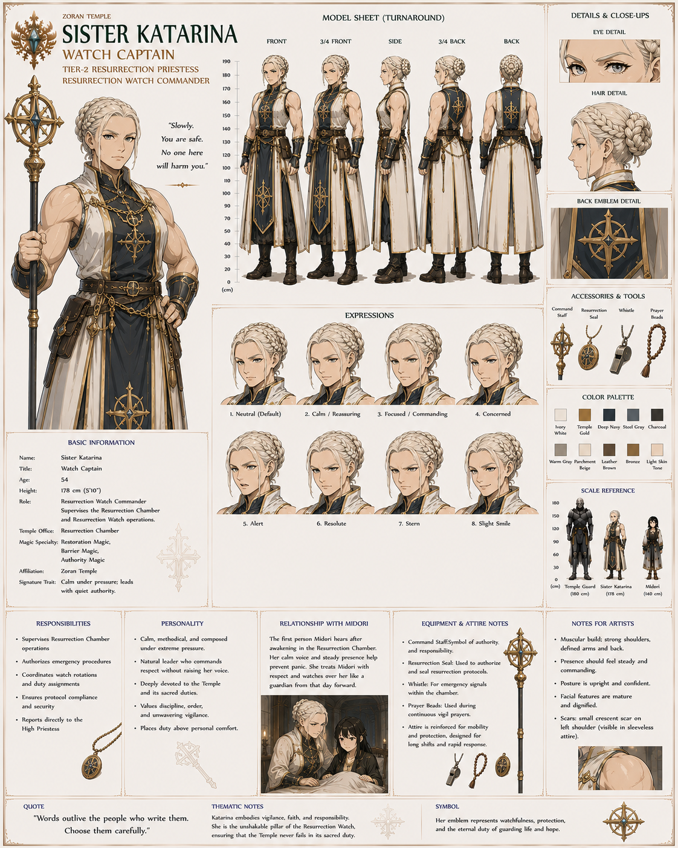

Sister Isolde

Crystal Warden
Age: 47
Temple Office
Senior Priestess — Mana Containment Specialist

Primary Responsibilities
- Monitors mana crystal stability
- Maintains containment barriers
- Measures ambient mana
- Oversees emergency crystal shutdowns

Personality
Analytical.
Curious.
Quietly fascinated by magical phenomena.
Frequently takes notes during unusual events.

Appearance
- Platinum-blonde hair tied into a practical bun
- Lavender eyes
- Wears crystal-measuring pendants at her belt

Midori Relationship
Immediately notices Midori's extraordinary mana signature.
She becomes one of Eliane's closest collaborators in studying the sealed Staff of Eternal Light.
Quote
"The readings... impossible. I've never seen mana behave like this."
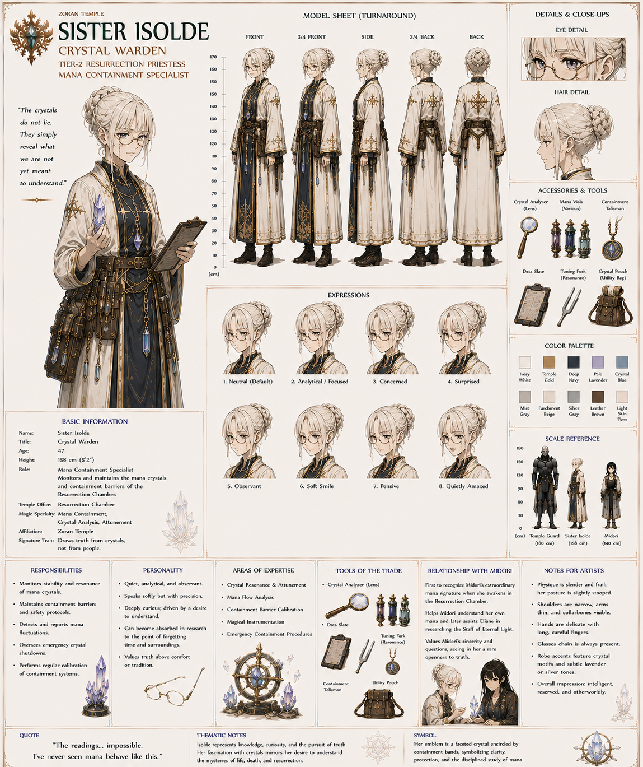

Sister Verena

Circle Keeper
Age: 50
Temple Office
Senior Priestess — Ritual Maintenance

Primary Responsibilities
- Maintains resurrection circles
- Repairs ritual inscriptions
- Verifies magical geometry
- Oversees ceremonial preparations

Personality
Patient.
Perfectionist.
Treats every ritual circle as sacred artwork.

Appearance
- Platinum-blonde hair in a long braided ponytail
- Pale violet eyes
- Fingers often stained with enchanted chalk pigments

Midori Relationship
She helped draw the resurrection circle that finally fulfilled Ashiba's prophecy.
Quietly emotional whenever she remembers that day.
Quote
"Two hundred years... and every line mattered."

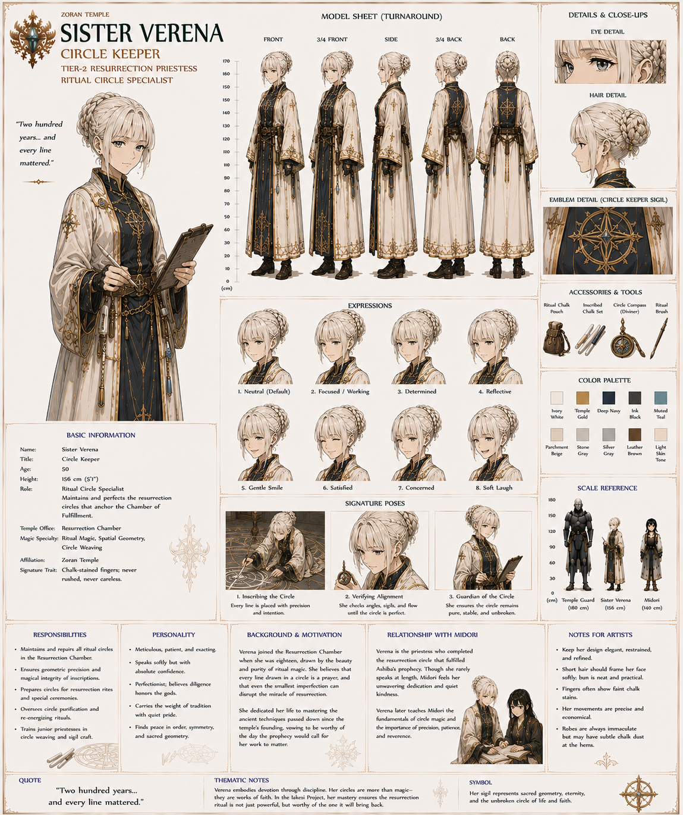

Sister Naomi

Prayer Keeper
Age: 33
Temple Office
Senior Priestess — Liturgical Coordinator

Primary Responsibilities
- Leads continuous prayer vigil
- Maintains sacred hymns
- Coordinates devotional rotations
- Preserves ceremonial tradition

Personality
Gentle.
Warm.
Compassionate.
Possesses remarkable emotional intuition.

Appearance
- Platinum-blonde hair parted on the left hand side
- Violet eyes
- Usually smiling softly

Midori Relationship
The first to comfort Midori after realizing she has awakened frightened and confused.
Midori never forgets her kindness.
Quote
"You don't have to understand everything today."

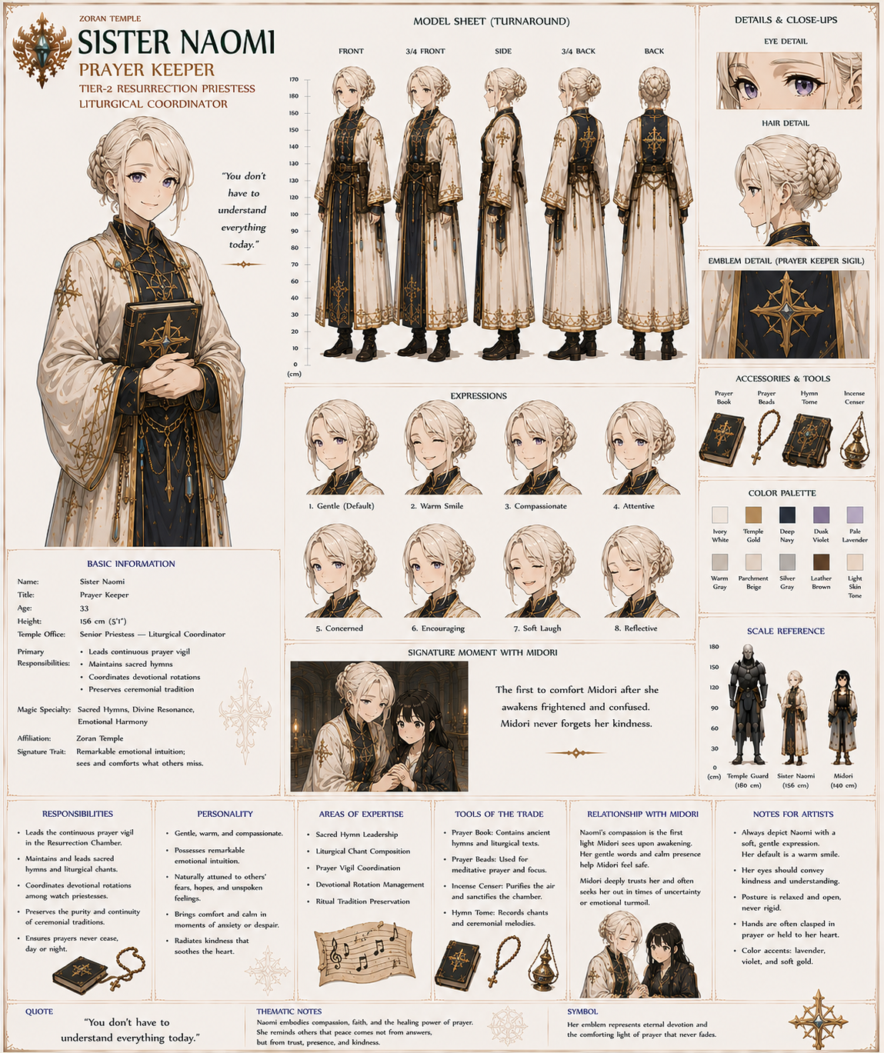

Sister Corinne

Chamber Archivist
Age: 49
Temple Office
Senior Priestess — Resurrection Records

Primary Responsibilities
- Documents Resurrection Chamber activity
- Maintains prophecy journals
- Records historical events
- Verifies ceremonial documentation

Personality
Observant.
Highly organized.
Rarely speaks unless she has something meaningful to add.

Appearance
- Platinum-blonde hair cut just below the shoulders and pinned neatly back
- Silver-gray eyes
- Always carries a leather-bound journal

Midori Relationship
Her official log becomes the first historical record to identify Midori as the prophesied Grand Mage.
Years later, Midori often consults her journals when researching the Temple's history.
Quote
"History begins the moment someone decides to write it down."
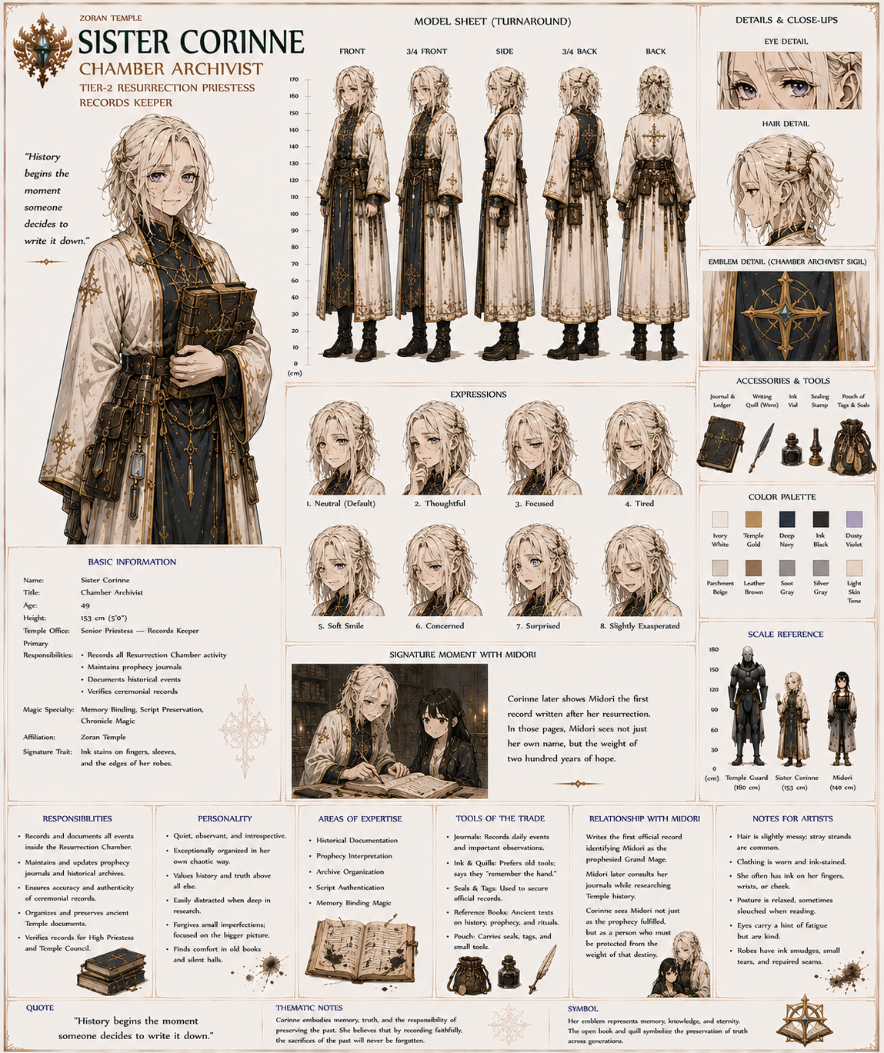

The First Witnesses
After Midori's resurrection, the five women become quietly famous within the Temple. Although they never seek recognition, younger priestesses often ask them what it was like to witness the fulfillment of Ashiba's prophecy.
Each remembers the moment differently:
- Katarina: remembers the responsibility.
- Isolde: remembers the unprecedented mana readings.
- Verena: remembers the completed resurrection circle.
- Naomi: remembers Midori's fear.
- Corinne: remembers writing the first line of a new chapter in Temple history.
Together, these five form a recurring supporting ensemble that gives the Resurrection Chamber emotional continuity. Whenever Midori returns to the Chamber later in the story, the reunion with the women who first welcomed her provides a natural reminder of how far she has come since arriving in the world of Zorna.

Tier 3 — Recurring NPCs
These appear repeatedly but don't need extensive biographies.

Tier 3 — Recurring Temple Staff

Sister Roselyn

Midori's Language Instructor
Age: 31
Position: Temple Language Instructor
Office: Temple Education Hall

Responsibilities
- Basic Zoran language
- Reading comprehension
- Vocabulary
- Conversation practice
- Pronunciation

Personality
Patient and encouraging.
Roselyn genuinely enjoys teaching beginners and quickly realizes that Midori is highly intelligent but constantly translating concepts from another world. She celebrates progress rather than perfection.

Relationship with Midori
Roselyn teaches Midori enough spoken and written Zoran that Lucia can later focus on higher academic subjects instead of basic literacy.
Quote
"You don't have to think like a Zoran overnight. First, let's simply learn how we speak."
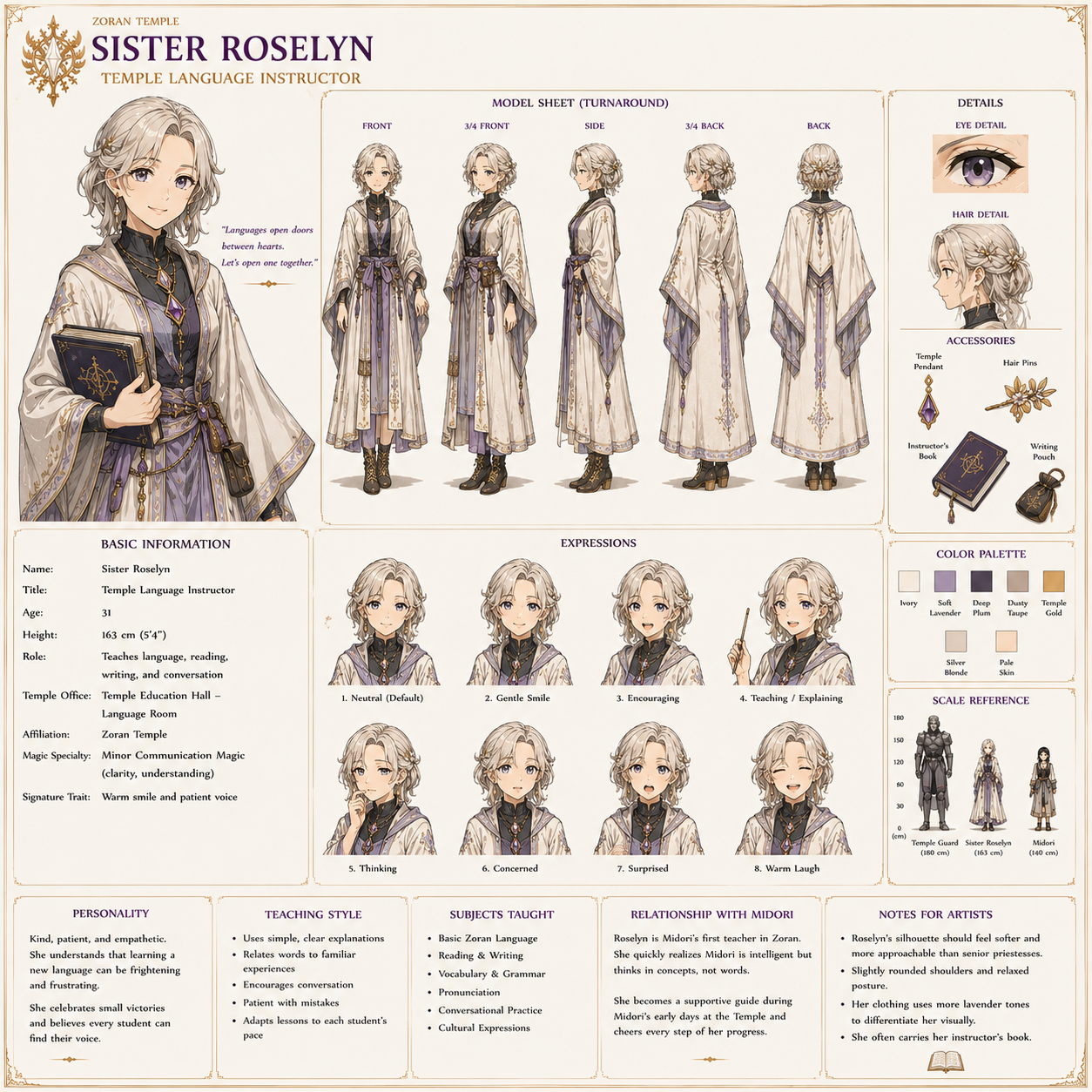

Brother Felix

Temple Librarian
Age: 67
Position: Chief Librarian
Office: Great Archive Reading Hall

Responsibilities
- Library administration
- Manuscript preservation
- Research assistance
- Catalog maintenance

Personality
Quiet, endlessly knowledgeable, and delighted whenever someone asks difficult questions.
Rather than giving answers immediately, he usually points visitors toward the correct shelf.

Relationship with Midori
He teaches Midori how the library is organized and becomes one of her favorite people to visit during her Temple education.
Miriam often jokes that Felix has memorized the entire catalog.
Quote
"The answer is somewhere on the third shelf... if you know where to begin looking."
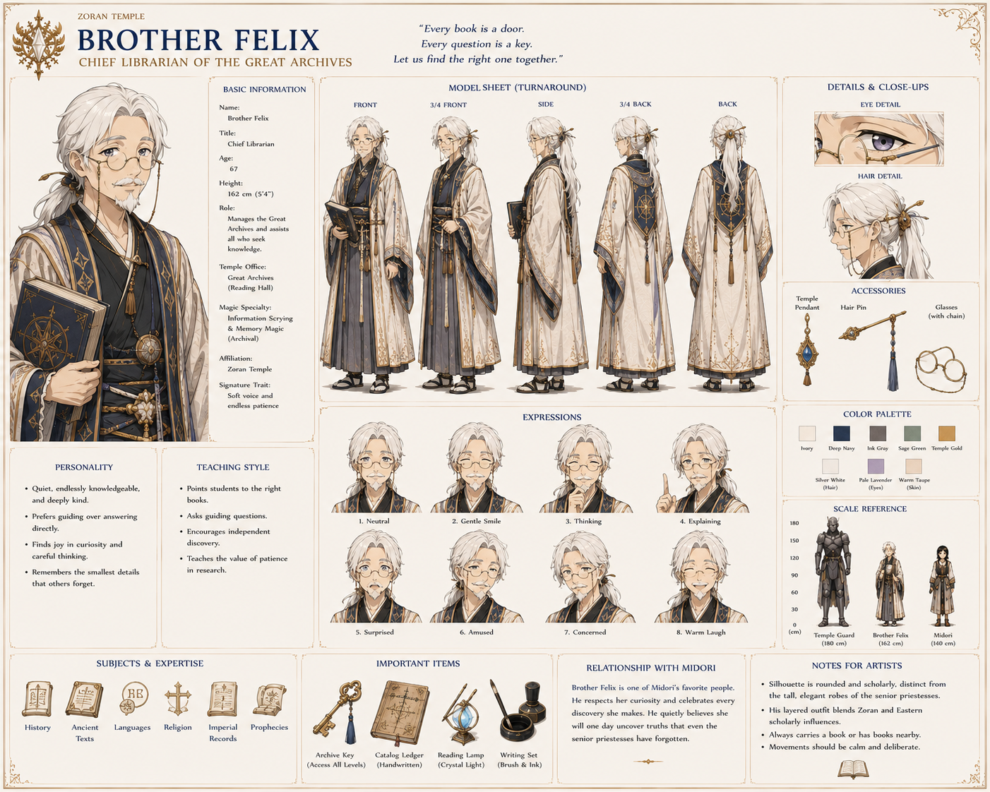

Sister Iris

Crystal Vault Master
Age: 44
Position: Crystal Vault Supervisor
Office: Crystal Vault Operations

Responsibilities
- Vault security
- Crystal inventory
- Mana shielding inspections
- Crystal transport authorization

Personality
Meticulous, disciplined, and exceptionally cautious.
She views mana crystals much the way a master engineer views dangerous machinery—valuable, but never to be treated casually.

Relationship with Midori
Frequently assists Eliane during practical lessons involving the Staff of Eternal Light and teaches Midori that every crystal has to be respected regardless of its size.
Quote
"Most crystal accidents begin with someone saying, 'It'll be fine.'"
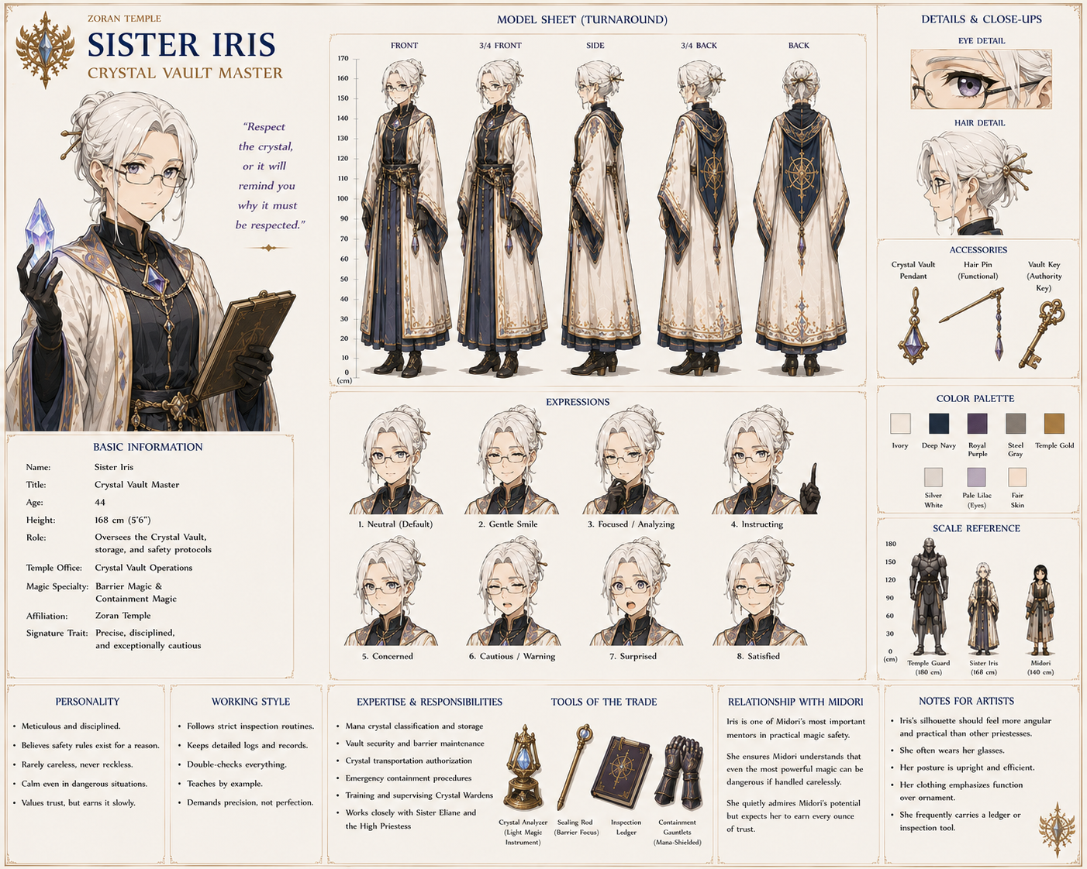

Sister Alina

Temple Physician
Age: 42
Position: Chief Temple Healer
Office: Temple Infirmary

Responsibilities
- Medical treatment
- Healing magic
- Mana poisoning
- Crystal exposure
- Long-term rehabilitation

Personality
Gentle, practical, and impossible to intimidate.
She has seen everything from paper cuts to battlefield injuries and treats every patient with the same calm professionalism.

Relationship with Midori
After training accidents or later battlefield injuries, Midori inevitably ends up in Alina's care. Alina insists that even the future Grand Mage must follow doctor's orders.
Quote
"You may argue with generals, High Priestesses, and even the Emperor if you must. You do not argue with your physician."

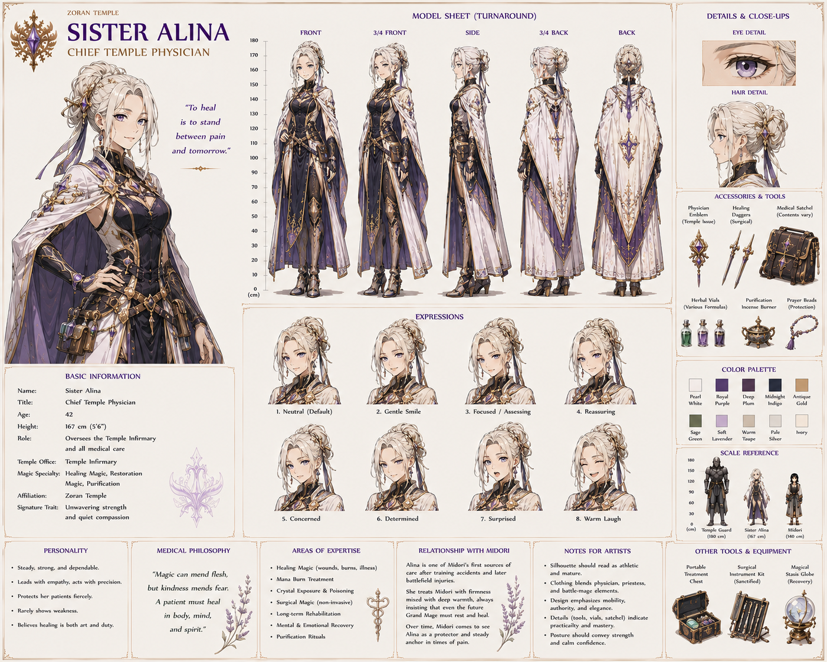

Brother Cedric

Temple Quartermaster
Age: 56
Position: Master of Temple Stores
Office: Supply Hall

Responsibilities
- Food stores
- Robes and equipment
- Furniture
- General logistics
- Inventory management

Personality
Organized, cheerful, and mildly obsessive about inventory.
He can tell if a single ceremonial candle is missing.

Relationship with Midori
Responsible for issuing Midori's robes, travel gear, and eventually preparing supplies before she leaves for the Imperial Magic Academy.
Quote
"If I can't find it, the Temple probably doesn't own it."

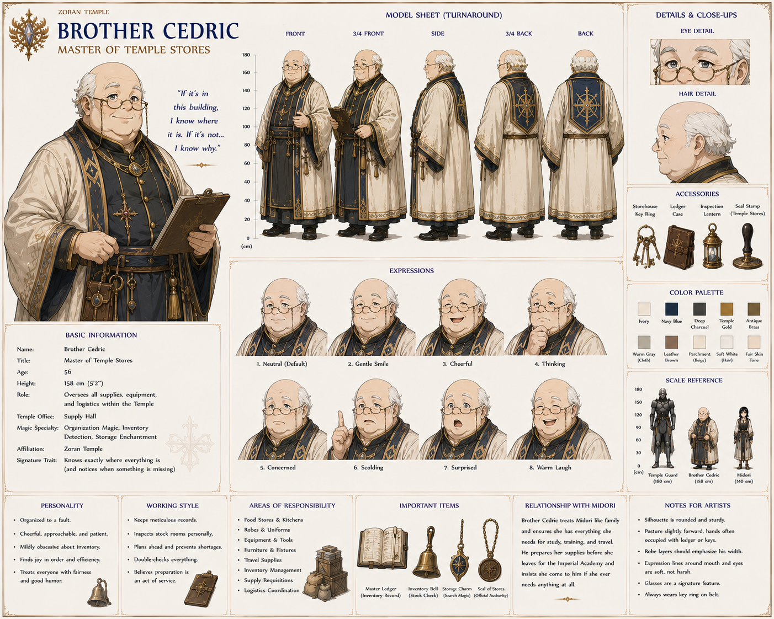

Sister Linnea

Temple Gardener
Age: 38
Position: Keeper of the Sacred Gardens
Office: Temple Gardens

Responsibilities
- Sacred flowers
- Healing herbs
- Memorial gardens
- Ashiba's Grove

Personality
Soft-spoken and reflective.
She believes gardens teach patience better than lectures.

Relationship with Midori
Often notices when Midori needs a quiet place to think and welcomes her into the gardens without asking questions.
Quote
"Even the strongest tree spends years growing roots."
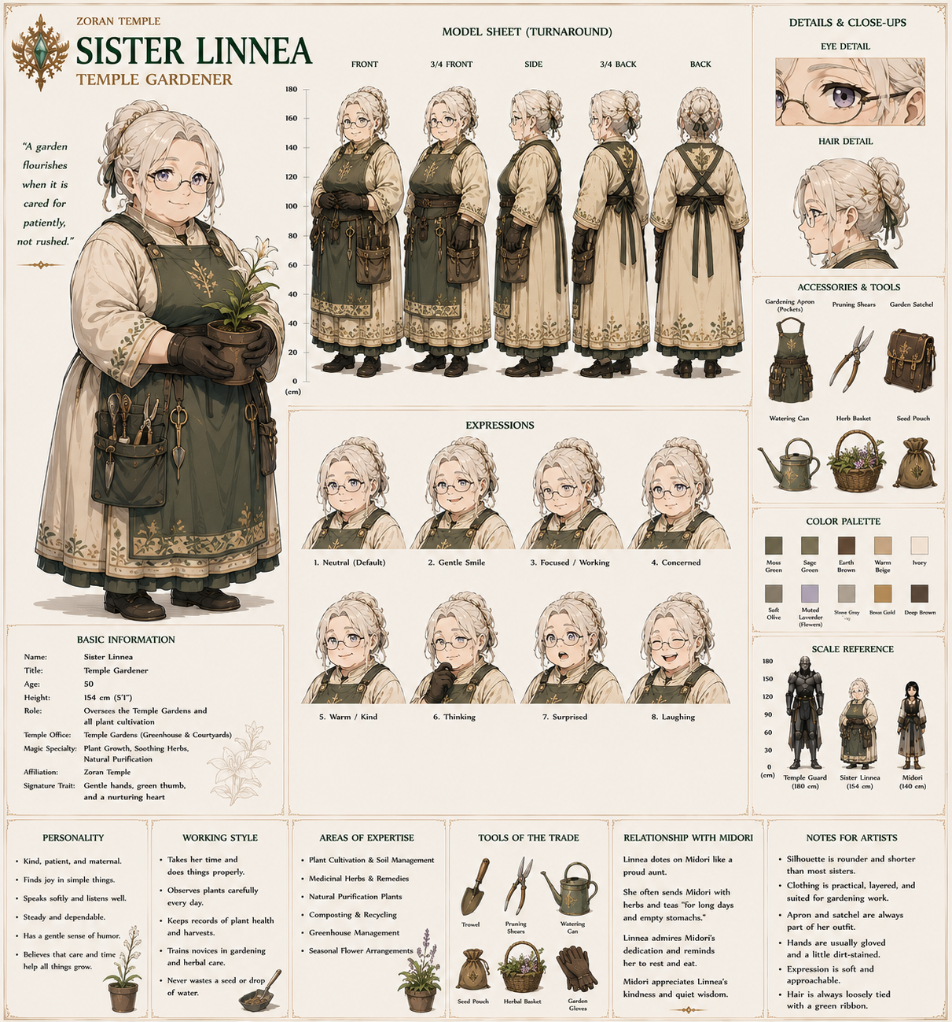

Brother Matthias

Master Scribe
Age: 53
Position: Chief Temple Scribe
Office: Records Hall

Responsibilities
- Official correspondence
- Imperial documents
- Temple decrees
- Record preservation

Personality
Precise, formal, and deeply devoted to accuracy.
His handwriting is considered the standard for official Temple documents.

Relationship with Midori
Helps her prepare formal reports and official correspondence before she enters the Imperial Academy.
Quote
"Words outlive the people who write them. Choose them carefully."
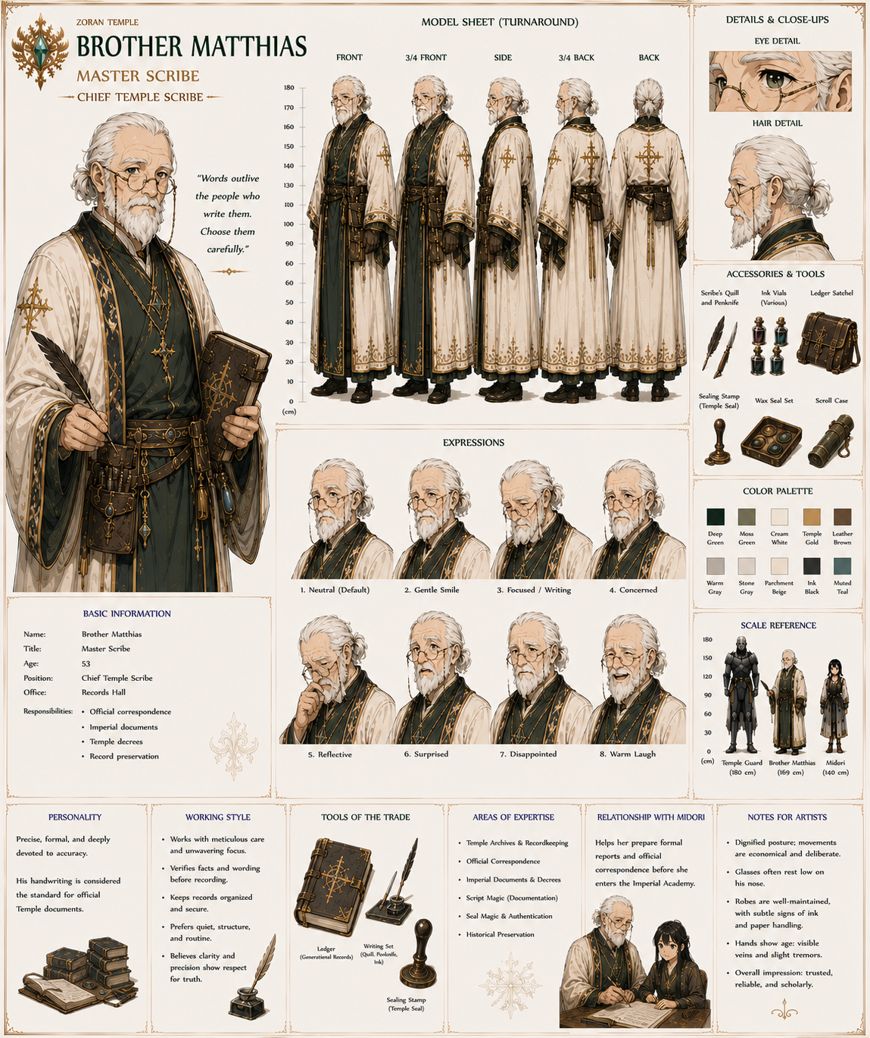

Purpose in the Story
These Tier 3 characters give each part of the Temple a familiar face:
- Education: Sister Roselyn
- Library: Brother Felix
- Crystal Vault: Sister Iris
- Infirmary: Sister Alina
- Logistics: Brother Cedric
- Gardens: Sister Linnea
- Records: Brother Matthias
They appear often enough that readers recognize them, but they don't require the extensive production package reserved for the High Priestess, the Order of Ashiba, or other major supporting characters. They make the Temple feel like a living institution staffed by specialists rather than a collection of anonymous background figures.

Tier 4 — Functional NPCs
No names initially.
Examples:
- Temple guards
- Kitchen workers
- Garden keepers
- Junior priestesses
- Administrative clerks
- Laundry attendants
If one becomes important later, you can promote them.

The Six Tutors
You mentioned:
Six priestesses tutor Midori.
I think these should definitely be named.
Each can teach a different subject:
Tutor | Specialty
Language | Reading and writing Zoran
History | Empire and Temple history
Etiquette | Customs, protocol, noble behavior
Theology | Religion and Temple doctrine
Basic Magic | Mana theory and introductory spellcasting
Physical Training | Staff handling, fitness, and battlefield discipline
This also gives Midori six distinct mentor relationships instead of one generalized "training montage."

Handled by the Order of Ashiba.

Summary
Here's how I'd allocate development effort:
Role | Count | Name? | Full Backstory?
High Priestess | 1 | ✅ | ✅
Deputy High Priestess | 1 | ✅ | ✅
Ashiba | 1 | ✅ | ✅
Order of Ashiba | 6 | ✅ | Moderate
Resurrection Watch | 5 | ✅ | Brief
Midori's Tutors | 6 | ✅ | Moderate
Temple Librarian | 1 | ✅ | Brief
Crystal Vault Master | 1 | ✅ | Brief
Temple Physician | 1 | ✅ | Brief
Guards, attendants, novices, kitchen staff, gardeners | 100+ | ❌ | ❌
That gives you about 22 named Temple characters, which is enough for the Temple to feel alive without overwhelming the reader.
One additional thought: because the Temple is a matriarchal institution, it would help establish its culture if each of those named priestesses represented a different philosophy about Midori. Some might see her as the prophesied savior, others as a child in need of guidance, others as a political liability because of her black hair, and at least one might privately suspect the prophecy has been misunderstood. Those differing viewpoints create natural tension within the Temple without requiring outright villains.

Iakesi Production Bible — Spiritual Foundation

Purpose
The teachings of Ashiba guide every member of the Order.
Novices begin memorizing the Principles during their first mon at the Academy.
Senior Priestesses quote them naturally during instruction, ceremonies, counseling, and military service.
The Principles are neither laws nor commandments. They are ideals by which members of the Order strive to live.

The Ten Principles

1. Humanity Endures Together.
"No mage stands alone. No village stands alone. Our strength is shared, or it is lost."
The Temple exists to preserve humanity, not individuals acting in isolation.

2. Power Exists to Protect.
"The measure of strength is not what it can destroy, but what it preserves."
Magic is entrusted to defend life, not to seek glory or domination.

3. Every Mage Is Precious.
"A lifetime of learning is not spent lightly."
The loss of a mage is mourned not only as a personal tragedy but as the loss of years of knowledge and service. This principle explains the Temple's extraordinary investment in healing, recovery, and careful training.

4. Knowledge Wins Wars Before Armies Do.
"The spell perfected today saves lives tomorrow."
Research, scholarship, and teaching are considered forms of service equal to fighting on the battlefield.

5. Teach Without Jealousy.
"What you keep dies with you. What you teach lives beyond you."
Every senior priestess bears responsibility for preparing those who will one day replace her.

6. Compassion Gives Power Its Purpose.
"Without compassion, victory is only another form of ruin."
Even in wartime, healing and mercy remain sacred duties.

7. Truth Does Not Fear Examination.
"Faith grows stronger when tested honestly."
The Temple encourages careful observation, scholarship, and the refinement of magical understanding. Discovery is viewed as honoring creation rather than challenging it.

8. Steward Every Gift.
"Crystals, knowledge, time, and life are entrusted to us for those who follow."
Wastefulness is considered both a practical and moral failing.

9. Guard Hope.
"When hope survives, humanity survives."
Priestesses are expected to strengthen the courage of others through their conduct as much as through their magic.

10. Leave the World Stronger Than You Found It.
"The next generation must inherit more than our victories."
Every act of teaching, healing, preserving knowledge, or rebuilding after war is considered part of Ashiba's covenant with humanity.

Use in Daily Life
The Principles are quoted frequently but naturally.
Examples:
A student hesitates to share a new spell.
"Teach Without Jealousy."
A commander requests exhausted mages remain on the front.
"Every Mage Is Precious."
A researcher wants to skip documenting an experiment.
"Truth Does Not Fear Examination."
An instructor reminds students to help refugees before repairing buildings.
"Power Exists to Protect."

I made one significant change from the original list: I centered the Principles on institutional identity rather than abstract morality.
If a reader encountered these sayings throughout Iakesi, they would quickly understand what makes the Order of Ashiba distinct. The Temple's defining values become clear: preserve humanity, value every trained mage, pass knowledge forward, wield power responsibly, and never lose sight of hope. Those principles arise directly from a civilization fighting a centuries-long existential war, making them feel like the lived philosophy of the world rather than a collection of generic proverbs.



